Martin Niemöller: "First they came for the Socialists..."
Martin Niemöller (1892–1984) was a prominent Protestant pastor who emerged as an outspoken public foe of Adolf Hitler and spent the last seven years of Nazi rule in concentration camps. Niemöller is perhaps best remembered for the quotation (quote) below.
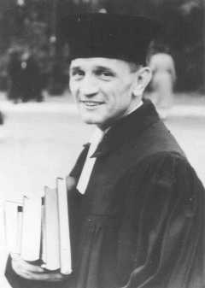
Martin Niemöller, a prominent Protestant pastor who opposed the Nazi regime. He spent the last seven years of Nazi rule in concentration camps. Germany, 1937.
First they came for the Socialists, and I did not speak out—
Because I was not a Socialist.
Then they came for the Trade Unionists, and I did not speak out—
Because I was not a Trade Unionist.
Then they came for the Jews, and I did not speak out—
Because I was not a Jew.
Then they came for me—and there was no one left to speak for me.

Bildarchiv Preussischer Kulturbesitz
United States Holocaust Memorial Museum. “Introduction to the Holocaust.” Holocaust Encyclopedia. www.ushmm.org/wlc/en/article.php?ModuleId=10005143. Accessed on [3/29/16].

WORDS TO KNOW IN THE QUOTATION
Socialist: a person who believes in a society in which major industries are owned and controlled by the government rather than by individual people and companies (different from a democratic society like ours).
Trade unionist: a person who supports labor unions (organization of workers formed to protect the rights and interests of its members).
Jew: someone whose religion is Judaism, who is descended from Jewish people, or who participates in the culture surrounding Judaism.

